WIPRO CAPSTONE PROJECT
Test Analysis Report

BlazeDemo Flight Booking Automation Framework
Selenium WebDriver · TestNG · Maven · ExtentReports · Jenkins · Docker

Project Name | BlazeDemo Flight Booking Automation Framework
Document Type | Test Analysis Report
Prepared By | Mr. Baivab Sarkar
Mentor/ Trainer | Mrs. Vaishali Sonanis
Application Under Test | BlazeDemo
URL | https://blazedemo.com/
Positive Suite Result | PASS: 12/12 (100%)
Negative Suite Result | PASS: 3/3 (100%)
Defects Logged | 7 (BLAZE-7 to BLAZE-13)
Repository | ThisIs-Developer/Wipro-Capstone-Project
GitHub Link | https://github.com/ThisIs-Developer/Wipro-Capstone-Project
Date | 13th June 2026

1. Executive Summary
This Test Analysis Report summarizes the results of testing conducted on the BlazeDemo Flight Booking web application. Testing was performed using Selenium WebDriver with the Page Object Model (POM) framework and TestNG. Two test suites were executed: a positive suite that tested the complete flight booking process with three sets of passenger data, and a negative test suite that checked the system's response to invalid inputs and Authentication module.
All test cases passed successfully, showing that the main booking process works as expected. However, 7 defects were identified and logged in JIRA.

2. Scope of Testing
The following modules were included in the testing scope:

- Home Page
- Flight Search
- Flight Selection
- Purchase Page
- Booking Confirmation
- Registration Page
- Login Page
The testing focused on validating critical business workflows and identifying application defects.
.

3. Testing Types Performed
- Functional Testing: Validated application functionality against expected behavior.

- End-to-End Testing: Verified the complete flight booking workflow from flight search to booking confirmation.

- Data-Driven Testing: Executed booking scenarios using multiple passenger datasets from Excel.

- Negative Testing: Validated application behavior using invalid, blank, and malformed inputs.

- Smoke Testing: Verified critical application functionalities before detailed execution.

- Regression Testing: Ensured framework stability across multiple executions.

- Cross-Browser Testing: Verified application functionality across different web browsers to ensure consistent behavior.

4. Test Case Design
Test Case ID | Test Case Name | Module | Status
TC001 | Verify Home Page | Home Page Module | PASS
TC002 | Verify Flight Search | Flight Search Module | PASS
TC003 | Verify Purchase Page | Purchase Module | PASS
TC004 | Verify Booking Confirmation | Confirmation Module | PASS
TC005 | Verify Registration Page | Authentication Module | FAIL
TC006 | Verify Login Page | Authentication Module | FAIL
TC007 | Booking With Blank Mandatory Fields | Purchase Module | FAIL
TC008 | Invalid Passenger Information | Purchase Module | FAIL
TC009 | Invalid Month Validation | Payment Module | FAIL
TC010 | Expired Year Validation | Payment Module | FAIL
TC011 | Mandatory Field Indicator | Purchase Module | FAIL
TC012 | Credit Card Length Validation | Payment Module | FAIL
5. Test Case Execution Analysis
- Positive Test Cases
TC ID | Test Case | Expected Result | Actual Result | Status
TC001 | Verify Home Page | Home page loads successfully | Home page loaded successfully | PASS
TC002 | Verify Flight Search | Available flights displayed | Flights displayed successfully | PASS
TC003 | Verify Purchase Page | Form submitted successfully | Form submitted successfully | PASS
TC004 | Verify Booking Confirmation | Confirmation page displayed | Confirmation page displayed | PASS
- Negative Test Cases
TC ID | Test Case | Expected Result | Actual Result | Status | Bug No (JIRA)
TC005 | Verify Registration Page | User registration successful | 419 Page Expired | FAIL | BLAZE-13
TC006 | Verify Login Page | User login successful | 419 Page Expired | FAIL | BLAZE-13
TC007 | Blank Mandatory Fields | Validation message displayed | Booking confirmed | FAIL | BLAZE-7
TC008 | Invalid Passenger Information | Validation message displayed | Booking confirmed | FAIL | BLAZE-8
TC009 | Invalid Month Validation | Month rejected | Booking confirmed | FAIL | BLAZE-9
TC010 | Expired Year Validation | Year rejected | Booking confirmed | FAIL | BLAZE-10
TC012 | Credit Card Length Validation | Validation message displayed | Booking confirmed | FAIL | BLAZE-12
Note: Although these test cases are marked as failed from an application perspective, they are considered successful from a testing perspective because they successfully identified reproducible defects.
- UI Test Cases
TC ID | Test Case | Expected Result | Actual Result | Status | Defect
TC011 | Mandatory Field Indicator | Mandatory fields marked | No indication available | FAIL | BLAZE-11
6. Suite-Level Test Execution Results
Test Suite | Suite File | Tests | Passed | Failed | Skipped | Result
FlightBookingSuite | testng.xml | 12 | 12 | 0 | 0 | PASS
NegativeTestSuite | testng-negative.xml | 3 | 3 | 0 | 0 | PASS
TOTAL | NA | 15 | 15 | 0 | 0 | PASS
7. Defects Logged in JIRA
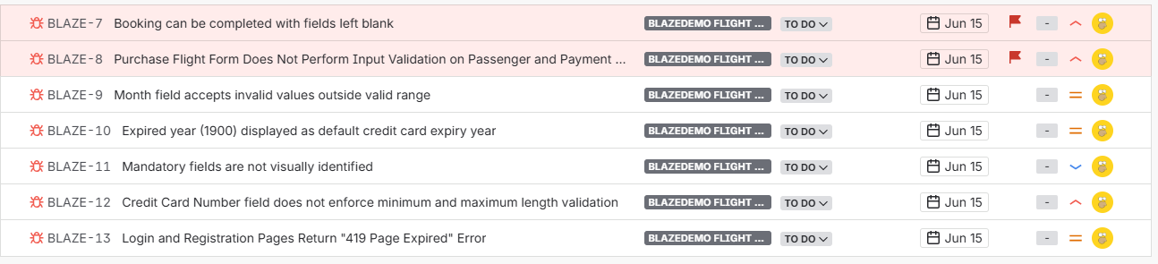

8. JIRA Defect Report
Defect ID | Title | Severity | Priority | Module | Status
BLAZE-7 | Booking can be completed with fields left blank | High | High | Purchase Page | TO DO
BLAZE-8 | Purchase Flight Form Does Not Perform Input Validation on Passenger and Payment Information | High | High | Purchase Page | TO DO
BLAZE-9 | Month field accepts invalid values outside valid range | Medium | Medium | Purchase Page | TO DO
BLAZE-10 | Expired year (1900) displayed as default credit card expiry year | Medium | Medium | Purchase Page | TO DO
BLAZE-11 | Mandatory fields are not visually identified | Low | Low | Purchase Page | TO DO
BLAZE-12 | Credit Card Number field does not enforce minimum and maximum length validation | Medium | High | Purchase Page | TO DO
BLAZE-13 | Login and Registration Pages Return "419 Page Expired" Error | High | High | Login Page / Registration Page | TO DO

9. Test Output

Run as TestNG Suite in IDE

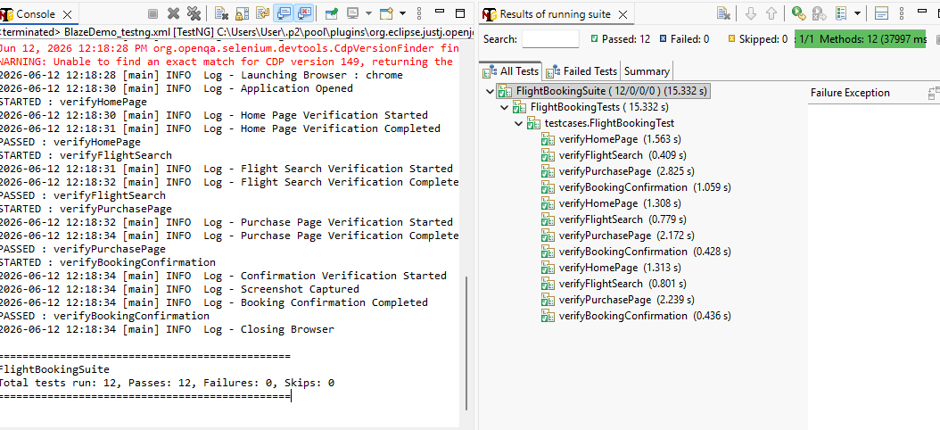

ExtentReport (.html)

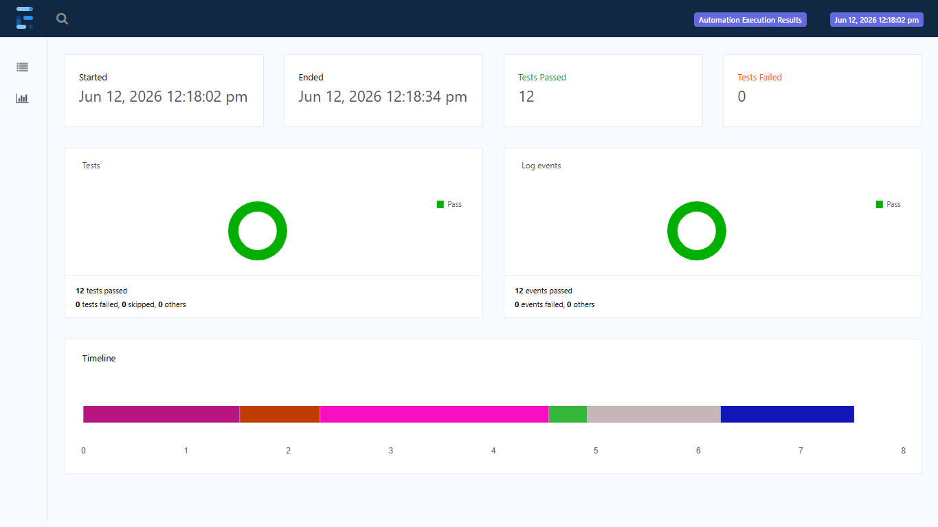

Mvn clean test

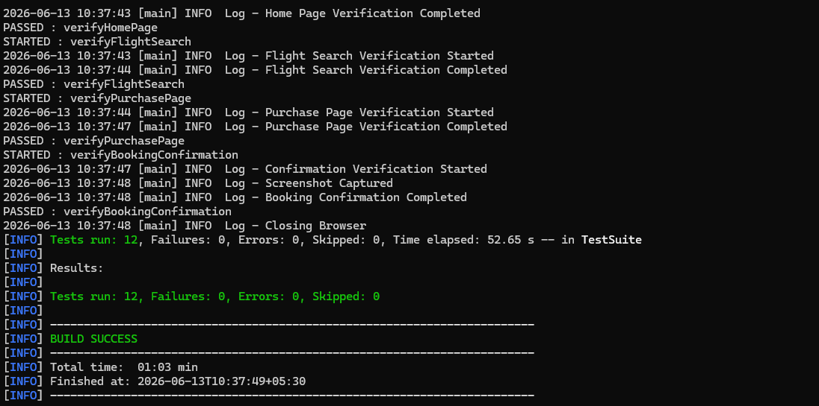

Jenkins runs
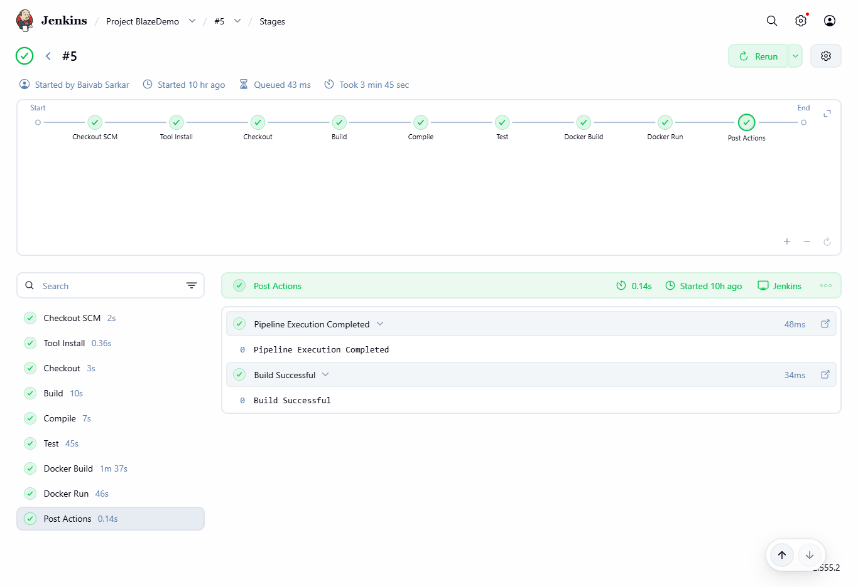

Docker Image Run and Logs

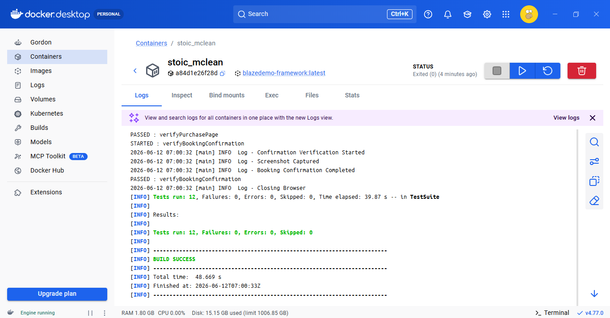
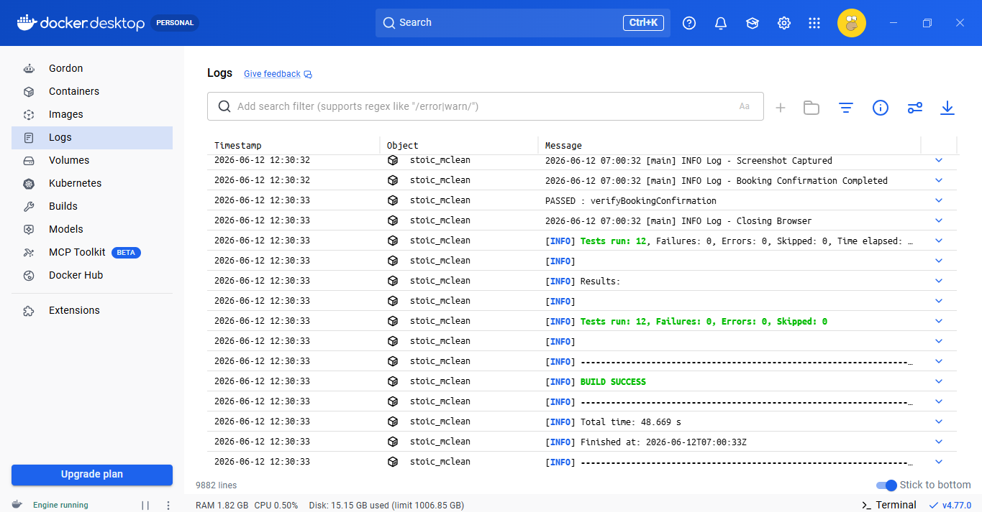

5. Conclusion
The BlazeDemo Flight Booking Automation Framework successfully validated the application's core booking functionality and achieved 100% test execution success. Testing identified 7 defects related to authentication and validation, while confirming that the end-to-end booking workflow functions correctly. Overall, the project met its testing objectives and demonstrated an effective, scalable automation framework with Jenkins and Docker integration.

